# 

Yuting Li

200434800

ENEL 489 Social and economic impacts of Artificial Intelligence

Project Proposal

Jun 7, 2022

1.0 Introduction

As technology develops, companies, organizations and even governments are seeking new opportunities to better fulfil people's needs or just to become more efficient in handling things by using the latest technologies such as big data, machine learning and artificial intelligence.

NorthPointe is a private company that developed and sells an artificial intelligence application that can examine the recidivism rate of prisoners (Julia 2016). Recidivism is a term used to describe the tendency of a prisoner to commit another crime after being released. This COMPAS algorithm will examine “more than 100 factors, including age, sex and criminal history. Notably, the race is not used.” (Corbett 2016) of a prisoner and assign him/her a score, from 1 to 10, the higher the score, the higher the probability of re-offending in the future.

In a research led by a non-profit published called ProPublica, researchers have collected information for over 10 thousand people that had committed a crime and were arrested in Florida’s Boward County. These prisoners are being scored by COMPAS and researched checked to see how many of them were charged with further crimes within two years (Julia 2016). The outcome of this research is shocking, the result showed that black defendants were twice as likely to be incorrectly labelled as having a higher risk than white defendants.

2.0 Scope

In this project, I will use Python to build and iterate an artificial intelligence software that can help eliminate racism. The inputs of my model will be modified from this [COMPAS questionnaire](https://www.documentcloud.org/documents/2702103-Sample-Risk-Assessment-COMPAS-CORE.html). The data for training and testing will be used from the [ProPublica Data Store](https://www.propublica.org/datastore/dataset/compas-recidivism-risk-score-data-and-analysis). However, if there are inconsistencies and conflicts or discrepancies between these two resources, I shall trust ProPublica Data Store.

3.0 Analysis of Issues

The researchers found that the accuracy of the COMPAS algorithm is actually very good, if the algorithm gives a prisoner an overall score of 1, the recidivism rate was only 22% while the prisoner who has an overall score of 10 has 81% of recidivism rate (Corbett 2016).

Also, the judgement of the crime rate is most afraid of being accused of racial discrimination, in real world scnario, black people are sometimes being assigned with a higher score. In COMPAS, race is not one of the inputs and statistics have found among the prisoner who was given a score of 7 by the algorithm if they are white, the subsequent recidivism rate will be 60% and if they are black, the scoring rate will be 61% (Corbett 2016). 1% difference is not significant and therefore COMPAS is a fair technology when predicting recidivism rate across races.

However, when pecifically counts cases of no re-offending but being assigned with a score of 5 or more. For the same prisoner who did not re-offend later, blacks were 42% more likely to be given high scores by the algorithm, while whites were only 22% likely.

4.0 Design Plan

Although the dataset of COMPAS is easy to access, the algorithm itself has been kept secret. I will first start my model with all inputs listed on the dataset, then, I will reduce the inputs and see if it is possible to generate such a precise model by solely reducing the inputs. The final objective is to reduce as much as inputs as possible yet maintaining the same level of precision.

5.0 Prototype system requirements

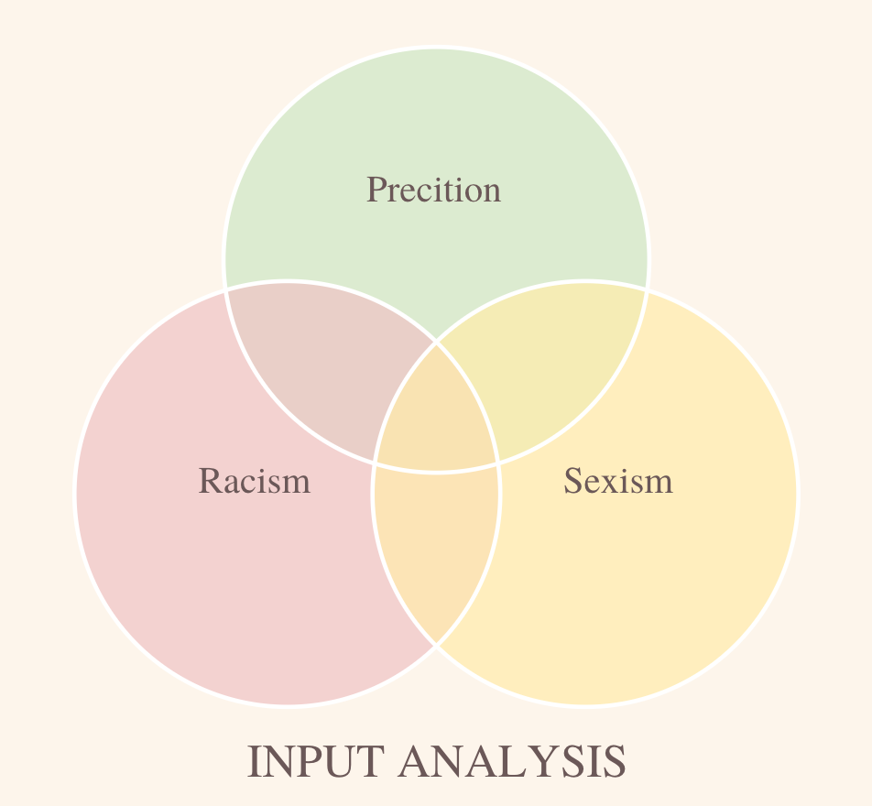

My goal is to identify among all those inputs, which of them solely contribute to the precision and will be kept in the algorithm. Then, inputs that are creating sexism and racism but not contributing to the precision will be discarded. Eventually, for inputs that can both provide precision and biases, I will have to make the trade-off of whether to keep them or not based on their actual effect on the whole system.

6.0 References

Julia Angwin and Jeff Larson, Bias in Criminal Risk Scores Is Mathematically Inevitable, Researchers Say, ProPublica, Dec. 30, 2016

Jeff Larson, J. A. (2016, May 23). How we analyzed the compas recidivism algorithm. ProPublica. Retrieved June 7, 2022, from https://www.propublica.org/article/how-we-analyzed-the-compas-recidivism-algorithm

Jon Kleinberg, Sendhil Mullainathan, Manish Raghavan, Inherent Trade-Offs in the Fair Determination of Risk Scores, arXiv:1609.05807 [cs.LG]

ProPublica. (n.d.). Compas recidivism risk score data and analysis. ProPublica Data Store. Retrieved June 7, 2022, from https://www.propublica.org/datastore/dataset/compas-recidivism-risk-score-data-and-analysis

Corbett-Davies, S., Pierson, E., Feller, A., & Goel, S. (2021, December 7). A computer program used for bail and sentencing decisions was labeled biased against blacks. it's actually not that clear. The Washington Post. Retrieved June 7, 2022, from https://www.washingtonpost.com/news/monkey-cage/wp/2016/10/17/can-an-algorithm-be-racist-our-analysis-is-more-cautious-than-propublicas/